**Practical No 11 Date:** 26/08/2023

**Title:** Write a Prolog program that captures Medical diagnostic system.

**Description:**

Words starting with lowercase are functors or constants. Words starting with capitals are variables.

Predication is the <head> :- <tail> clause.

A fact or hypothesis is a literal.

A functor whose syntax is the same for predicates and arithmetic functions has arity e.g., the number of arguments. arity=1 is unary, arity=2 is binary or for higher degree, just arity. For example

|  |  |
| --- | --- |
| male(george) | arity=1 |
| father(george,sue) | arity=2 |
| person(george, "999 Any Street", "Sometown", "State", 35) | arity=5 |

In medical diagnostic system, a diseases or diseases can be predicted based on symptoms. A combination of rules and facts can help in identification of diseases. For example, Symptoms like cold, fever, runny nose is indication of ‘Flu’. This can be written in Prolog using facts, functors and rules.

disease(X, flu):- symptoms(X, runny_nose), symptoms(X, cold), symptoms(X, fever)

**Program Code:**

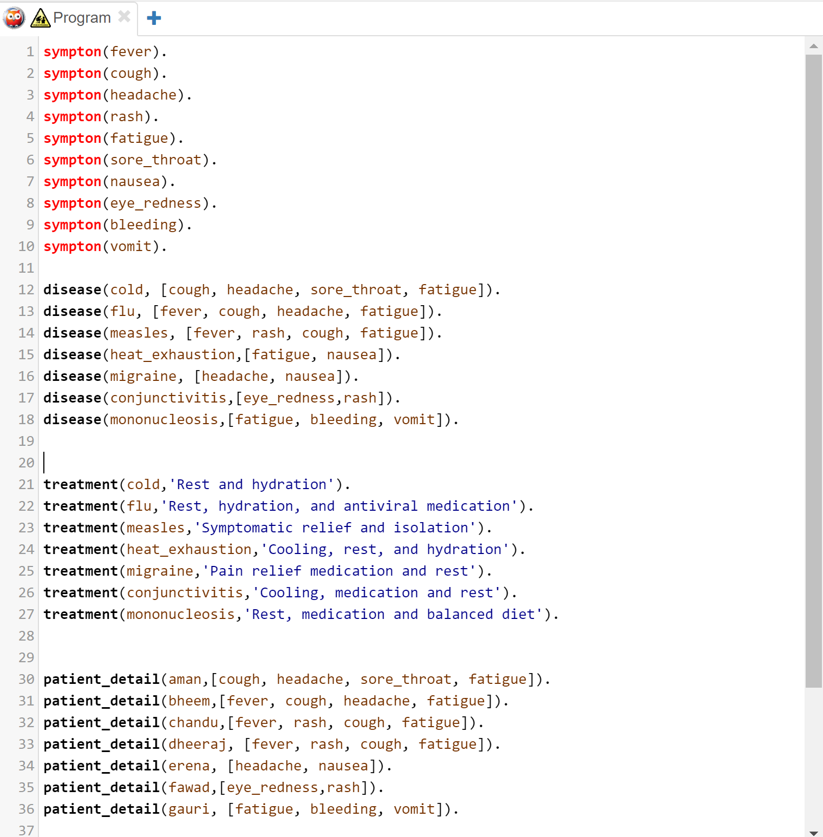

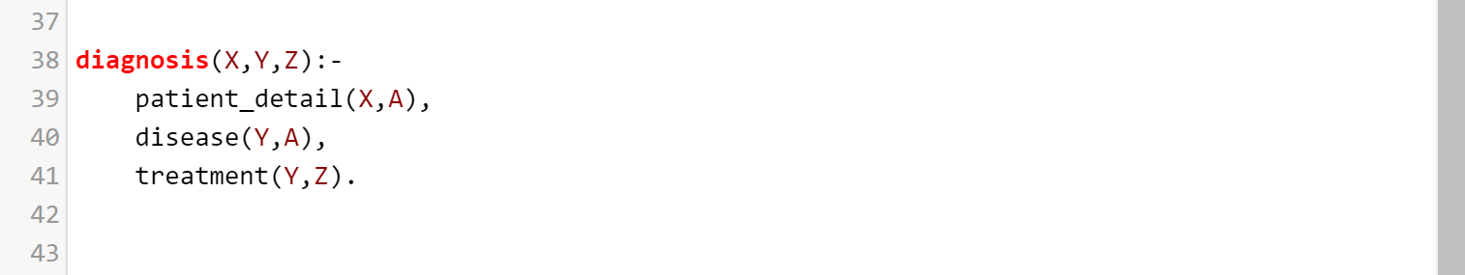

**Input and Output**

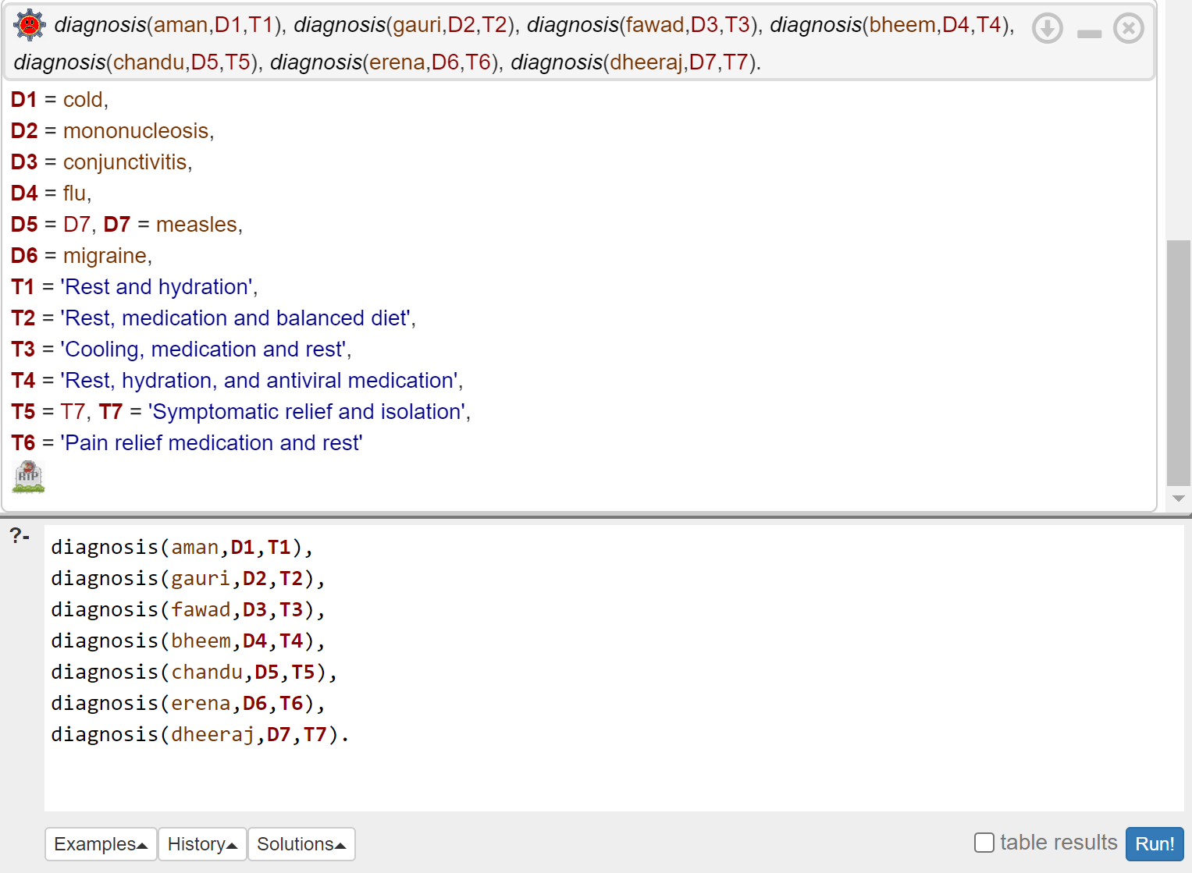

**Conclusion:** Thus we have created the knowledge base to capture basic medical diagnostic system.

**Practice programs:**

1. Create a knowledge base in Prolog which Captures the animal kingdom.
2. Create a knowledge base in Prolog which suggests the branch of study based on factors like interest, stream of study etc.